Project Design Phase
Solution Architecture

Date | 15 july 2026
Team ID
Project Name | Stock Trading App
Maximum Marks | 4 Marks

Solution Architecture:
- The Solution Architecture of SB Stocks defines how different components of the application work together to provide a secure and efficient paper trading platform. It connects user requirements with the MERN technology stack to deliver features such as authentication, stock management, virtual trading, portfolio tracking, and watchlist management.
Its goals are to:
- Design a secure and scalable MERN-based stock trading application.
- Define the interaction between the React frontend, Express backend, MongoDB database, and external stock market APIs.
- Provide a clear structure for user authentication, stock trading, portfolio management, and transaction processing.
- Ensure the application is maintainable, responsive, and easy to extend with future features such as AI-based recommendations and live trading support.

Example - Solution Architecture Diagram:

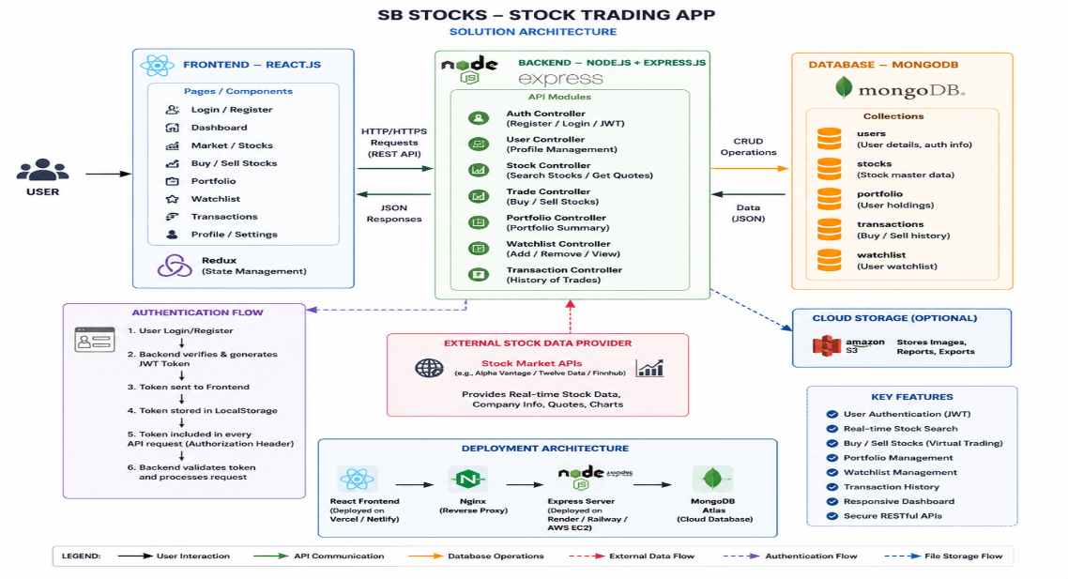
Figure 1: Architecture and data flow of the STOCK TRADING APP

